LAPORAN PENGERJAAN UJI KOMPETENSI KEJURUAN SMK MAHARDHIKA BATUJAJAR

TAHUN PELAJARAN 2022-2023

KOMPETENSI KEAHLIAN : Rekayasa Perangkat lunak KELAS :XII RPL 1

NAMA LENGKAP : M Iqbal Noviansyah

NIS : 2122.10.372

PAKET SOAL : 03

JENIS APLIKASI : Web Galeri foto

ALOKASI WAKTU : 24 jam

# PENJADWALAN KEGIATAN

*Silahkan buat form penjadwalan dengan excel seperti yang pernah dicontohkan*

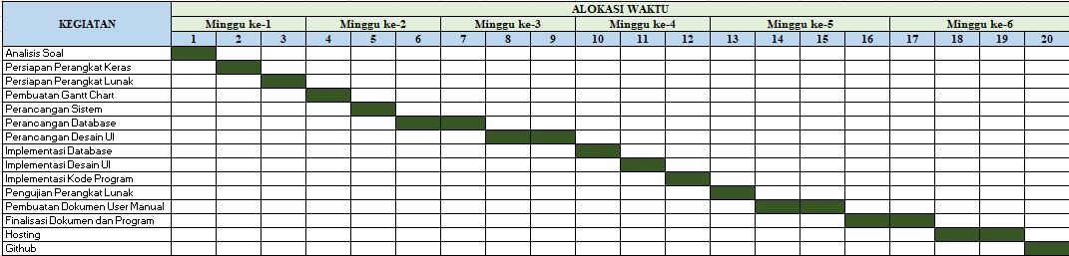

# PERSIAPAN PERANGKAT KERAS

*Silahkan isikan deskripsi/spesifikasi dari komputer/laptop yang kamu gunakan*

|  |
| --- |
| *Device name DESKTOP-7LLKFN8*  *Processor Intel(R) Core(TM) i3-10105F CPU @ 3.70GHz 3.70 GHz*  *Installed RAM 8,00 GB*  *Device ID 1F4726BD-D888-4288-907B-439CB779D116*  *Product ID 00330-80000-00000-AA809*  *System type 64-bit operating system, x64-based processor*  *Pen and touch No pen or touch input is available for this display*  *Edition Windows 10 Pro*  *Version 22H2*  *Installed on ‎29/‎08/‎2023*  *OS build 19045.3930*  *Experience Windows Feature Experience Pack 120.2212.3920.0* |

# PERSIAPAN PERANGKAT LUNAK

*Silahkan isikan perangkat lunak yang terlibat dalam pembuatan project ini*

|  |
| --- |
| *1. Visual Studio Code* |
| *2. Sublime Text* |
| *3.XAMPP Control Panel* |
| *4.Balsamiq* |
| *5.Astah Pro* |
| *6.Chrome* |
| *7.Microsoft Word* |
| *8. Microsoft excel* |

# PERANCANGAN ALGORITMA APLIKASI

*Silahkan gambarkan activity diagram aplikasi yang kamu buat*

1. *Register*

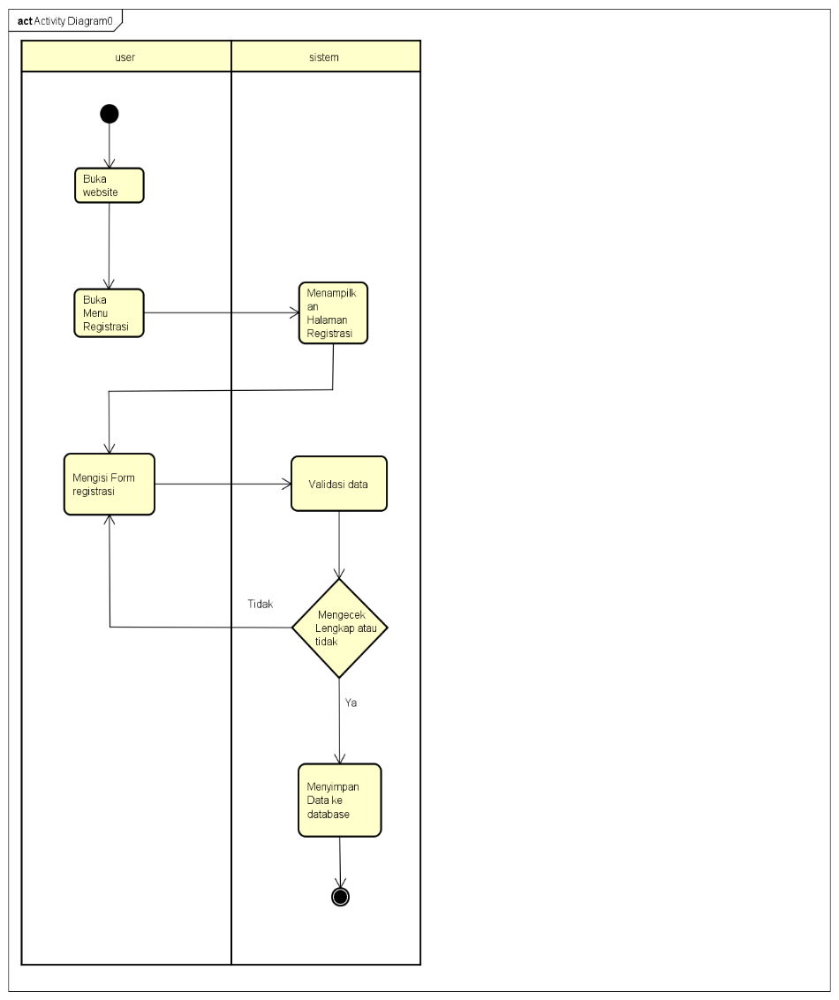

1. *Lihat foto*

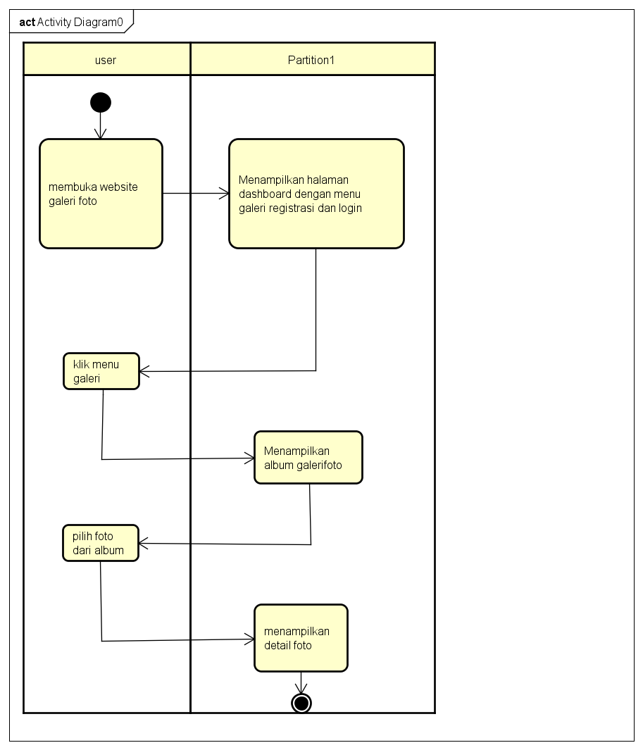

1. *Login*

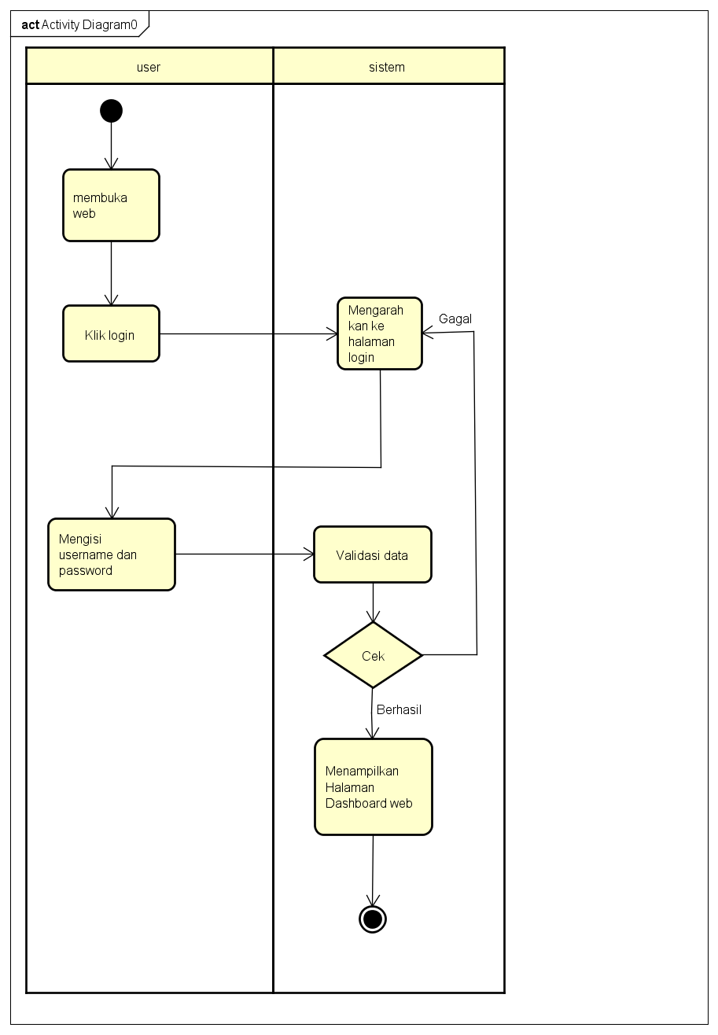

1. *Tambah foto*

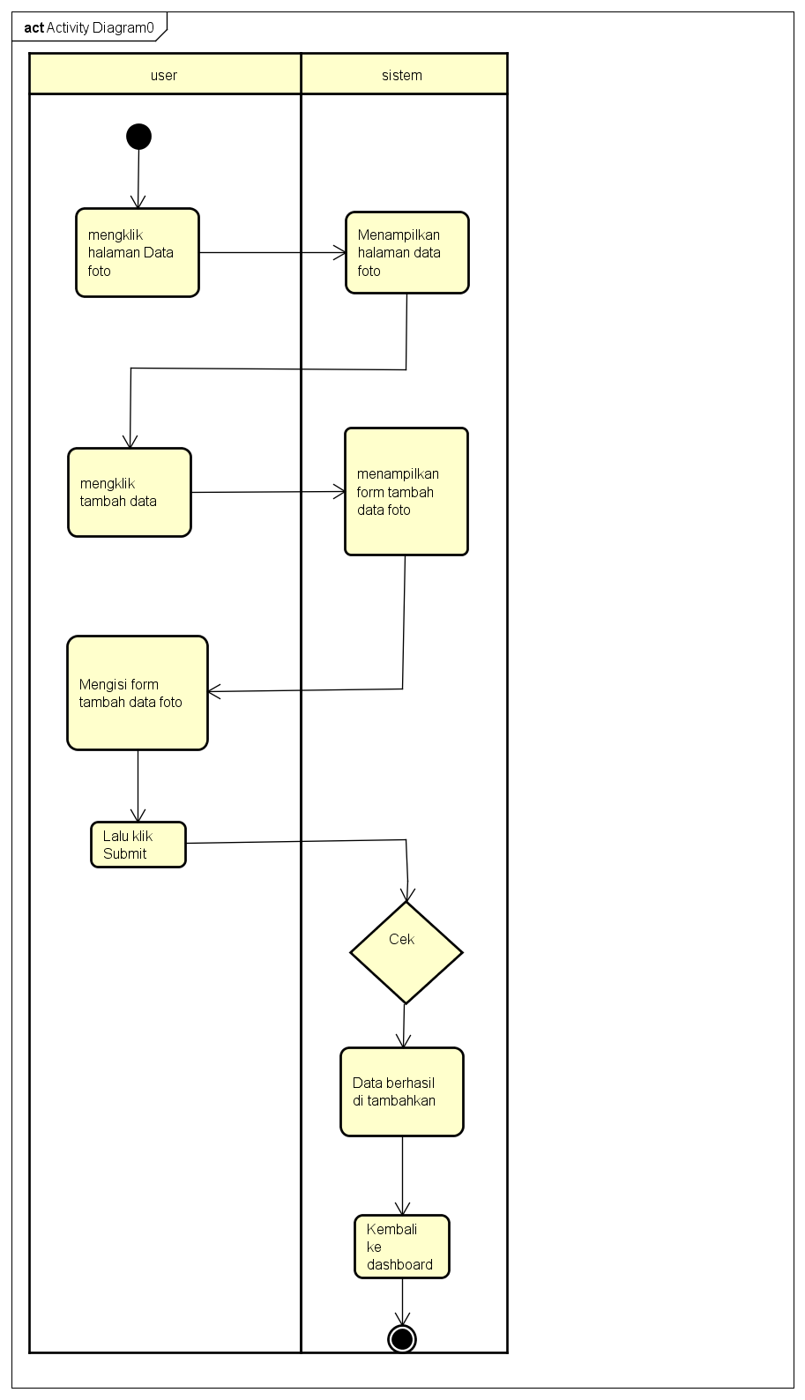

1. *Hapus foto*

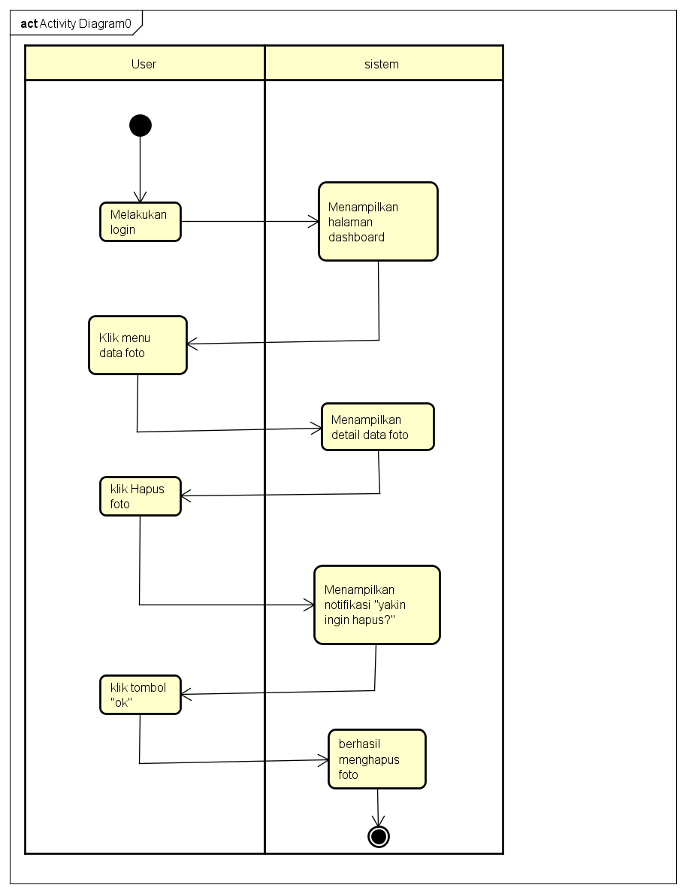

1. *Edit foto*

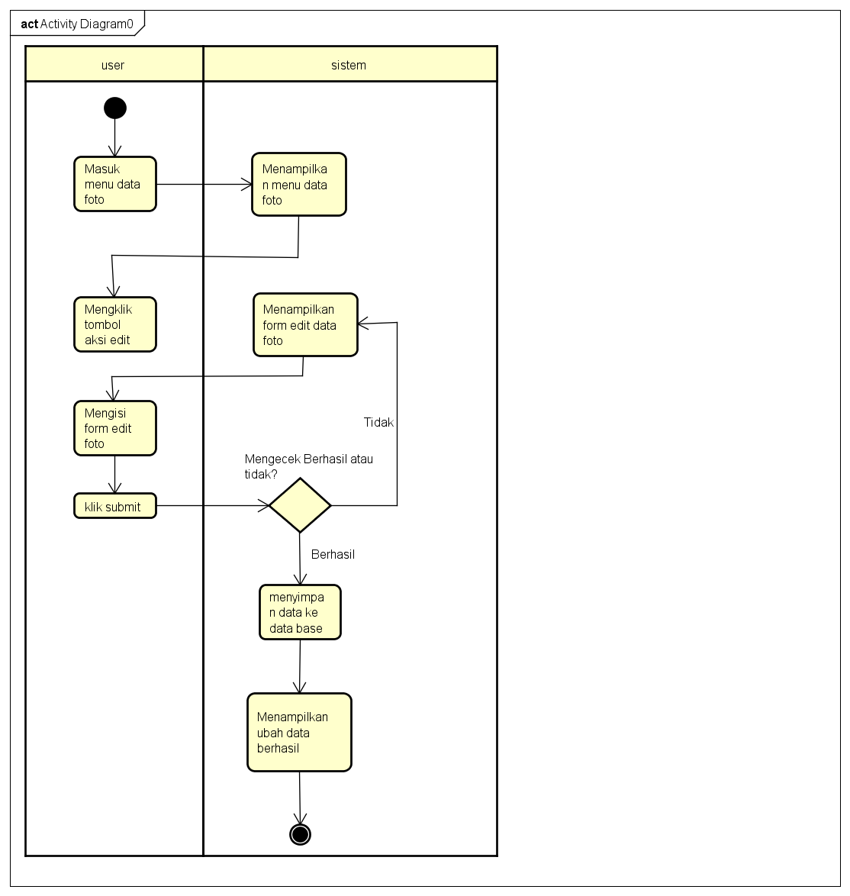

# PERANCANGAN DESAIN BASIS DATA

*Silahkan gambarkan ERD/DFD/class diagram atau desain basis data pada phpMyAdmin beserta relasinya*

1. *Class Diagram*

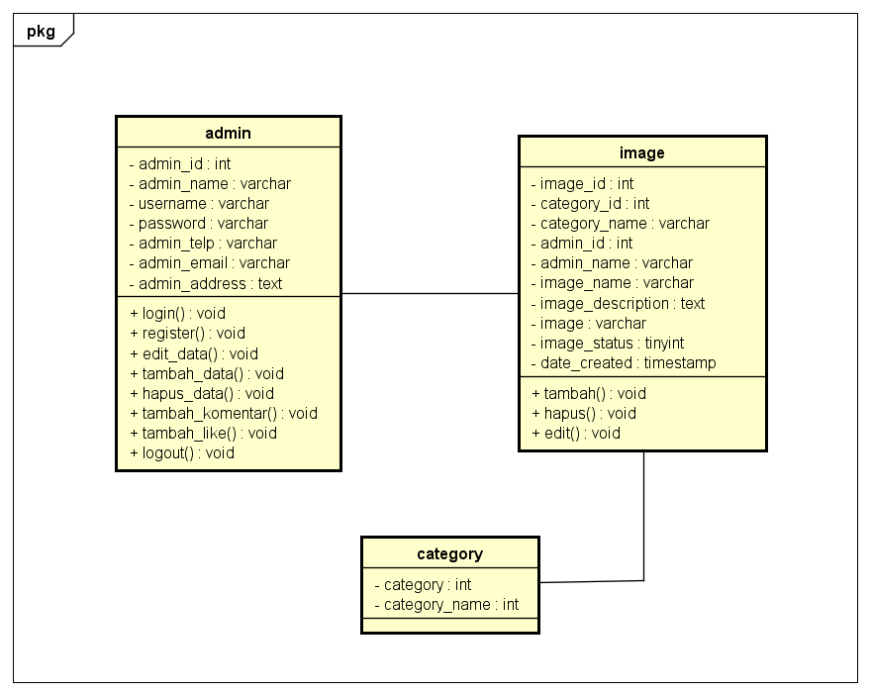

1. *ERD*
2. *ERD*

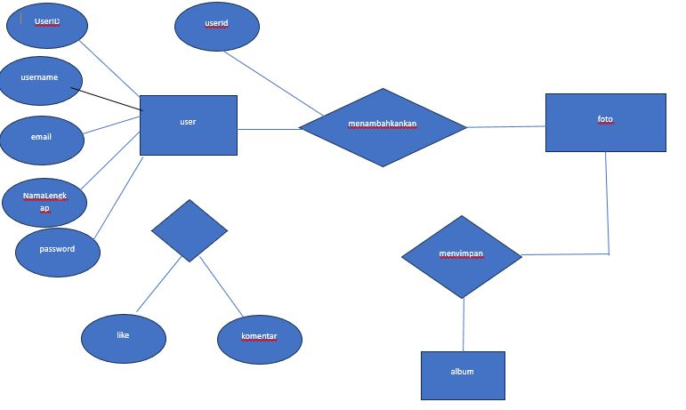

1. Relasi data Base

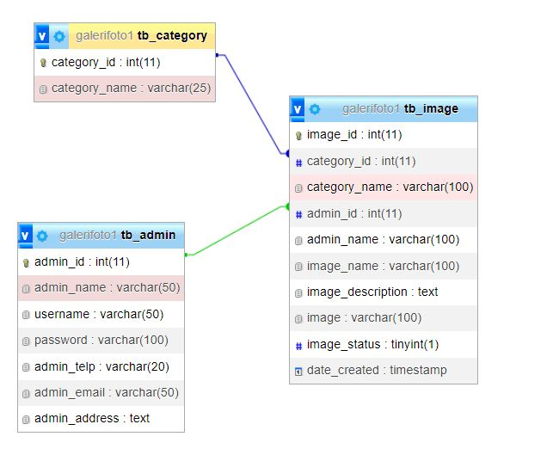

# DUMMY DATA

*Buat data dummy/bohongan yang dipersiapkan untuk nanti dimasukkan*

1. *tb_admin*

|  |  |  |  |  |  |  |  |  |  |  |
| --- | --- | --- | --- | --- | --- | --- | --- | --- | --- | --- |
| **admin_name** | **admin_id** | **username** | **password** | **admin_telp** | **admin_email** | **admin_adress** |  |  |  |  |
| Purrrrr | 7 | bals | 2005 | 02585445222 | iqbalnoviansyah@gmail.com | Cisiuk |  |  |  |  |
| Mhmdiqbalnoviansyah | 9 | iqbal | 2005 | 08584532228 | iqbalzrts@gmail.com | Cibeber |  |  |  |  |
| Cuprit | 10 | upri | 2005 | 0888509090 | rizkypratama773@smp.belajar.id | Cisiul |  |  |  |  |
| Adminan | 11 | admin | 2005 | 022958574 | melkipajarramadani@gmail.com | Sakung |  |  |  |  |

1. *tb_category*

|  |  |
| --- | --- |
| **Category_id** | **Category_name** |
| 14 | Perjalanan |
| 15 | Bawah Air |
| 16 | Hewan Peliharaan |
| 17 | Satwa Liar |
| 18 | Makanan |
| 19 | Olahraga |
| 123456 | Hewan |
| 66666666 | Sekolah |

1. *tb_mage*

|  |  |  |  |  |  |  |  |  |  |
| --- | --- | --- | --- | --- | --- | --- | --- | --- | --- |
| **Image_id** | **Category_id** | **Category_name** | **Admin_id** | **Admin_name** | **Image_name** | **Image_descrption** | **image** | **Image_status** | **Date_created** |
| 56 | [15](http://localhost/phpmyadmin/index.php?route=/sql&db=galerifoto1&table=tb_category&pos=0&sql_signature=f58c18e7887910a8e536496e2288260ef9538c1ec57983e46b49916e0ad1eeb0&sql_query=SELECT+%2A+FROM+%60galerifoto1%60.%60tb_category%60+WHERE+%60category_id%60+%3D+15) | Bawah Air | [7](http://localhost/phpmyadmin/index.php?route=/sql&db=galerifoto1&table=tb_admin&pos=0&sql_signature=72ec8de1760ca273cb7edd164b413ae4b463572ac9349a33bed20e0574838991&sql_query=SELECT+%2A+FROM+%60galerifoto1%60.%60tb_admin%60+WHERE+%60admin_id%60+%3D+7) | Purrrrr | mahardhika | smk mahardhika | foto1706931570.jpg | 1 | 2024-02-03 10:39:30 |
| 58 | [14](http://localhost/phpmyadmin/index.php?route=/sql&db=galerifoto1&table=tb_category&pos=0&sql_signature=630c7873fb93edf863a0acbc1ca54d66dee119b9d1c5c9404871b3daf45929fa&sql_query=SELECT+%2A+FROM+%60galerifoto1%60.%60tb_category%60+WHERE+%60category_id%60+%3D+14) | Perjalanan | [10](http://localhost/phpmyadmin/index.php?route=/sql&db=galerifoto1&table=tb_admin&pos=0&sql_signature=ecd965bc93213e23a708da02bd1b576861b4e9c3cad020846c58159b41039140&sql_query=SELECT+%2A+FROM+%60galerifoto1%60.%60tb_admin%60+WHERE+%60admin_id%60+%3D+10) | Cuprit | adadadad |  | foto1707122027.jpg | 1 | 2024-02-05 15:33:47 |
| 59 | [19](http://localhost/phpmyadmin/index.php?route=/sql&db=galerifoto1&table=tb_category&pos=0&sql_signature=473ea429e33ca9792f45fb46a53cca8682d76ab83d88412e170e380c77f3b543&sql_query=SELECT+%2A+FROM+%60galerifoto1%60.%60tb_category%60+WHERE+%60category_id%60+%3D+19) | Olahraga | [12](http://localhost/phpmyadmin/index.php?route=/sql&db=galerifoto1&table=tb_admin&pos=0&sql_signature=79ed6a4b860d65ce62af3c8820a352d63f1e29187f258647ce184934ade3f6ae&sql_query=SELECT+%2A+FROM+%60galerifoto1%60.%60tb_admin%60+WHERE+%60admin_id%60+%3D+12) | Hasanudin | timnas | Ini adalah foto timnas voly indonesia | foto1707182716.jpg | 1 | 2024-02-06 08:25:16 |
| 60 | [19](http://localhost/phpmyadmin/index.php?route=/sql&db=galerifoto1&table=tb_category&pos=0&sql_signature=473ea429e33ca9792f45fb46a53cca8682d76ab83d88412e170e380c77f3b543&sql_query=SELECT+%2A+FROM+%60galerifoto1%60.%60tb_category%60+WHERE+%60category_id%60+%3D+19) | Olahraga | [11](http://localhost/phpmyadmin/index.php?route=/sql&db=galerifoto1&table=tb_admin&pos=0&sql_signature=921ecc89c1b264c437b25b0f9d5ff565444c50c010f11cc8dab436c89049c8c6&sql_query=SELECT+%2A+FROM+%60galerifoto1%60.%60tb_admin%60+WHERE+%60admin_id%60+%3D+11) | Adminan | 333 | 333 | foto1707182925.png | 1 | 2024-02-06 08:28:45 |

# PEMBUATAN BASIS DATA (MySQL Code)

*Silahkan buat basis data di PHPMyAdmin, jika sudah selesai bisa di copykan filenya di sini sebagai lampiran (*screenshot struktur tabel pada basis data yg dibuat)*

1. *tb_admin*

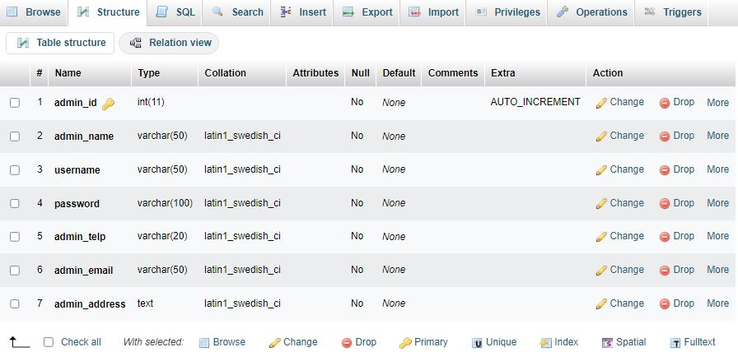

1. *tb_category*

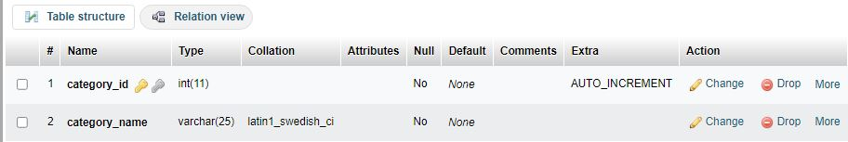

1. *tb_image*

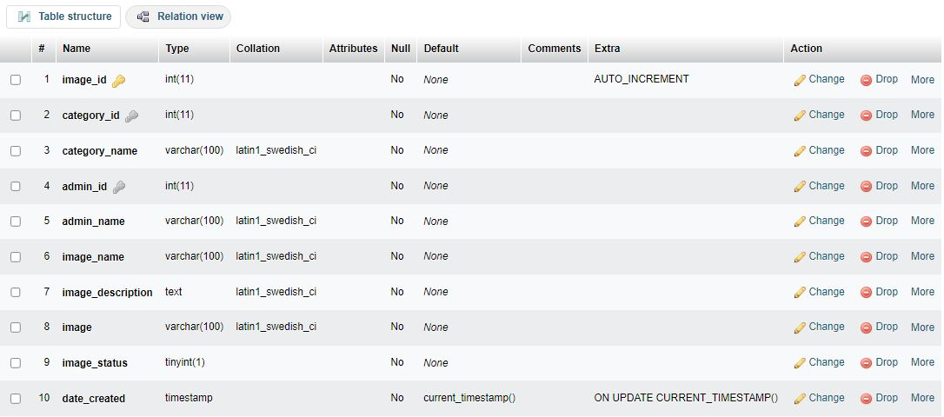

# PERANCANGAN TAMPILAN ANTARMUKA (UI) WEB

1. *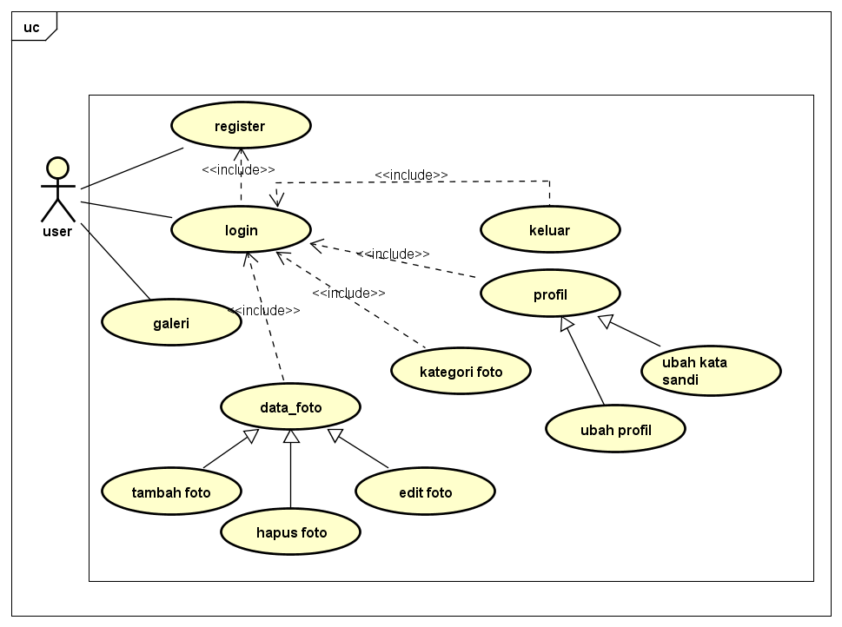UseCase diagram*

*Scenario UseCase*

AKTOR: User

Nama : Login

ID : UC1

|  |  |
| --- | --- |
| Scenario Utama | |
| Aksi Aktor | Reaksi Sistem |
| Membuka Website | Menampilkan Halaman utama |
| Memilih halaman Login | Menampilkan halaman login |
| Mengisi username dan password |  |
|  | Memproses Username dan password yang telah diisi |
| User Berhasil Masuk Ke halaman dashboard |  |
| Scenario Alternatif | |
| Jika username dan password yang di masukan tidak sesuai maka reaksi sistem akan Kembali kehalaman login Lagi |  |

Nama : Tambah data foto

ID : UC2

Aktor : User

|  |  |
| --- | --- |
| Aksi Aktor | Reaksi sistem |
| 1. Membuka Halaman data foto | 1. Menampilkan halaman data galeri foto |
| 1. Mengklik form Tambah data | 1. Menampilkan form tambah data foto |
| 1. Mengisi form pilih Kategori foto, id foto, nama foto, Deskripsi ,tambah data foto dan pilih status |  |
|  | 1. Mengecek dan menyimapn data yang telah ditambahkan |
| 1. Berhasil menambahkan data foto |  |
| Scenario alternatif | |
| Jika user tidak mengisi salah satu form Tambah data  maka tidak bisa menambahkan data foto | |

AKTOR: User

Nama : Hapus foto

ID : UC3

|  |  |
| --- | --- |
| Scenario Usecase | |
| Aksi Aktor | Reaksi sistem |
| 1. Membuka Halaman data foto | 1. Menampilkan halaman data galeri foto |
| 1. Mengklik form Tambah data | 1. Menampilkan form tambah data foto |
| 1. Mengklik aksi hapus | 1. Menampilkan kata “yakin ingin hapus” |
| 1. Mengklik Ok | 1. Foto berhasil di hapus |
| Scenario Alternatif | |
|  | |

AKTOR : User

Nama : edit foto

ID : UC4

|  |  |
| --- | --- |
| Scenario Usecase | |
| Aksi aktor | Reaksi Sistem |
| 1. Masuk ke menu data foto | 1. Menampilkan menu data foto |
| 1. Mengklik Tombol aksi edit | 1. Menampilkan form edit data foto |
| 1. Mengisi form edit foto |  |
| 1. Klik submit | 1. Mengecek dan menyimpan data terbaru ke data base |
|  | 1. Menampilkan ubah data berhasil |

Nama : Detail foto

ID : UC5

Actor : user

|  |  |
| --- | --- |
| Scenario Utama | |
| Aksi Aktor | Reaksi Sistem |
| Membuka website galeri foto | Menampilkan halaman dashboard dengan menu galeri, registraasi dan login |
| 3. Klik tombol galeri | 4. Menampilkan album galeri foto |
| Memilih foto dari dalam album | Menampilkan detail foto |
| Scenario alternatif | |
|  |  |

1. Register

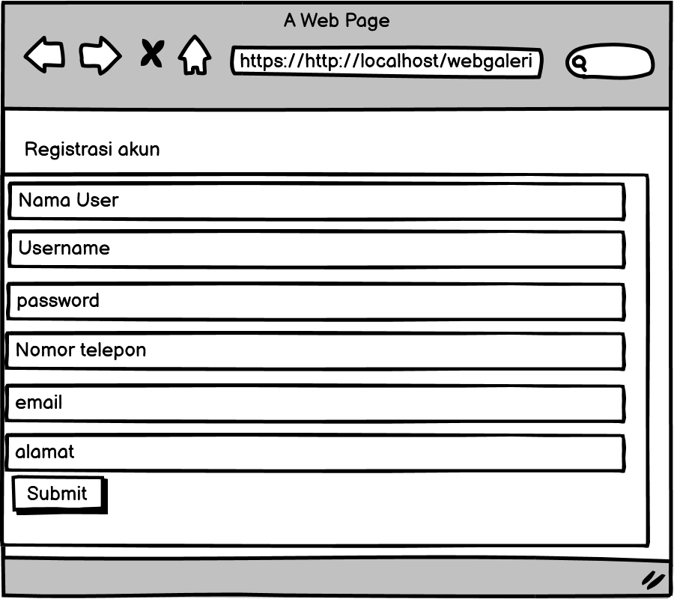

1. LOGIN

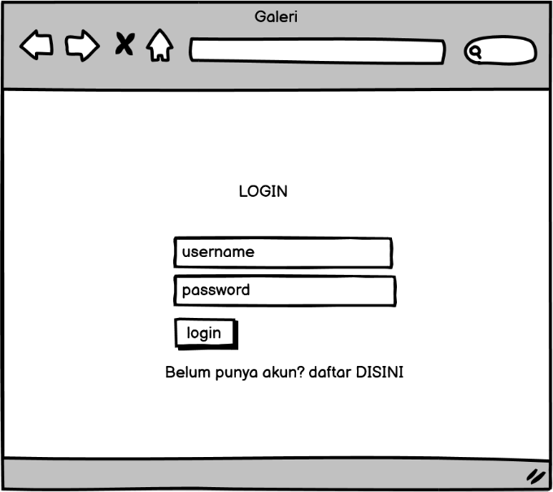

1. Dashboard

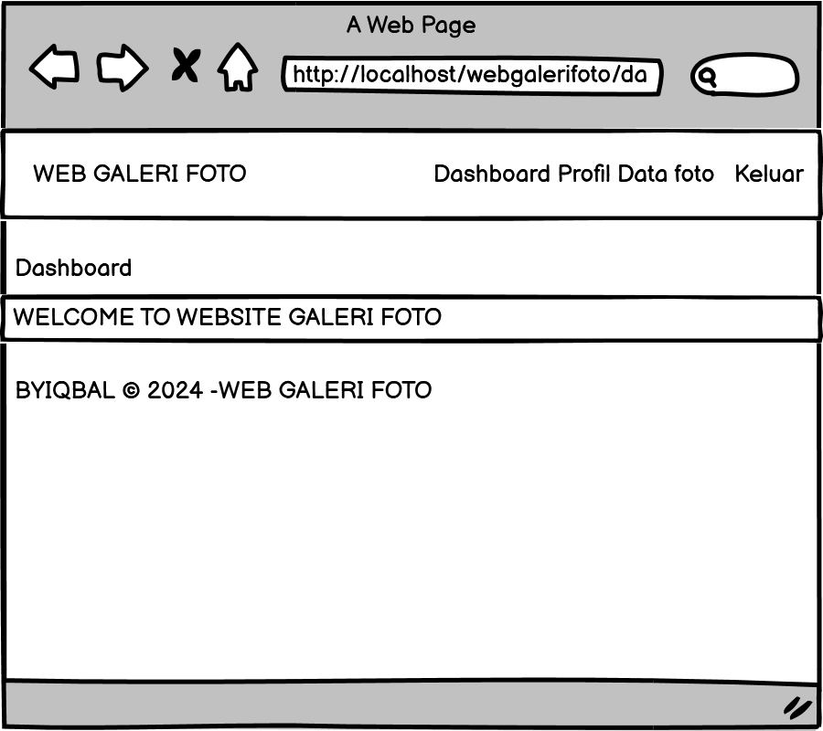

1. Tambah foto

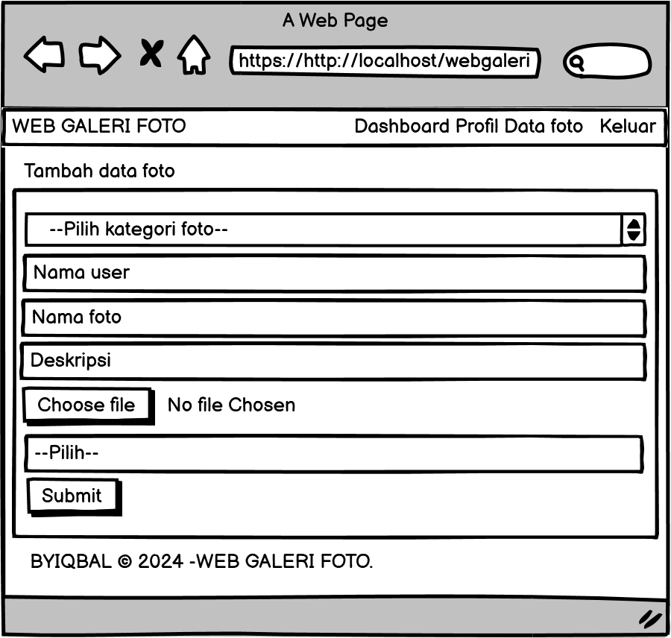

1. 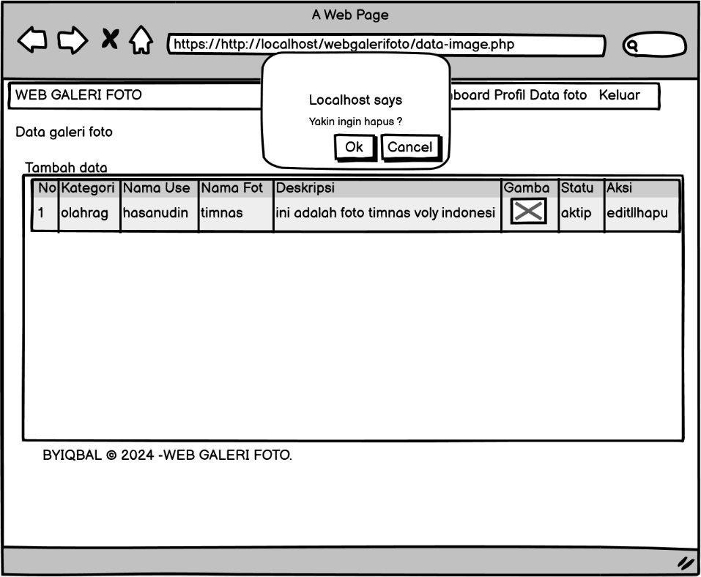Hapus foto
2. Edit foto

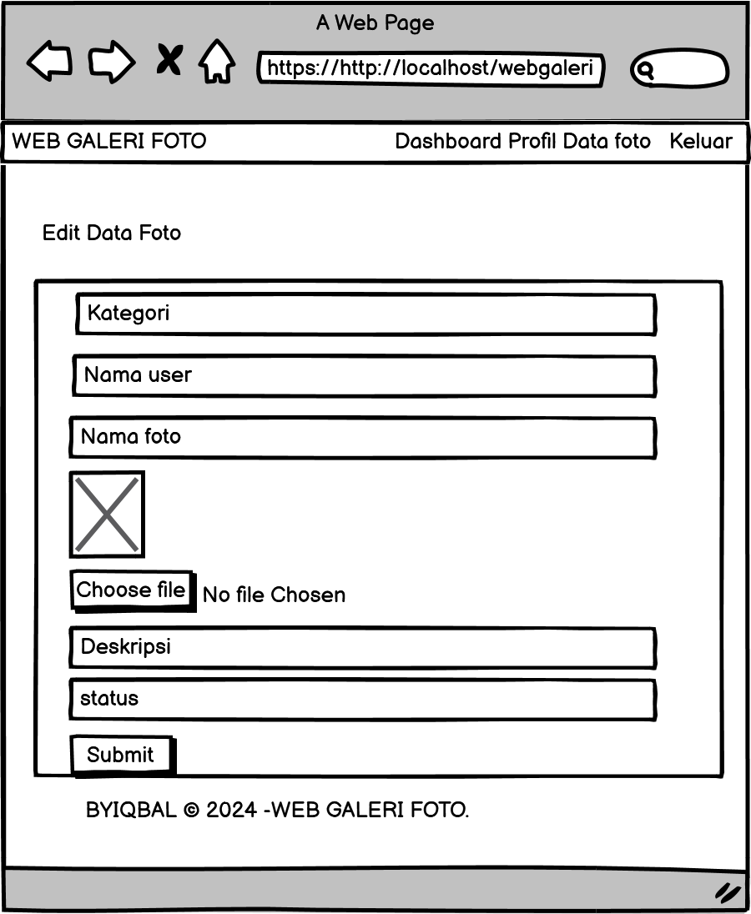

1. Llike dan comment

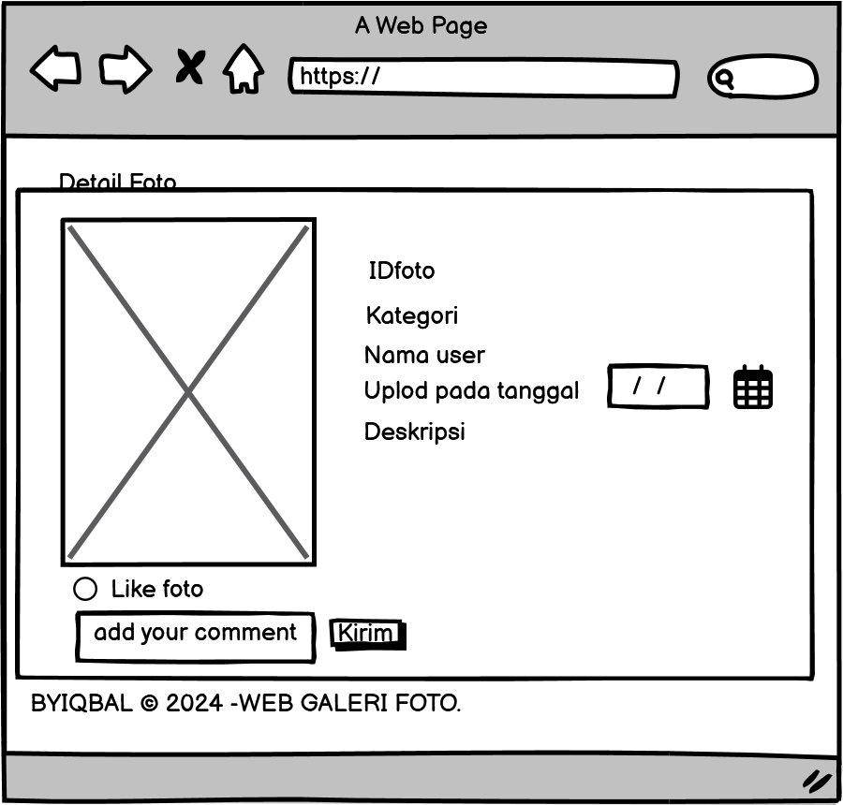

1. Profil

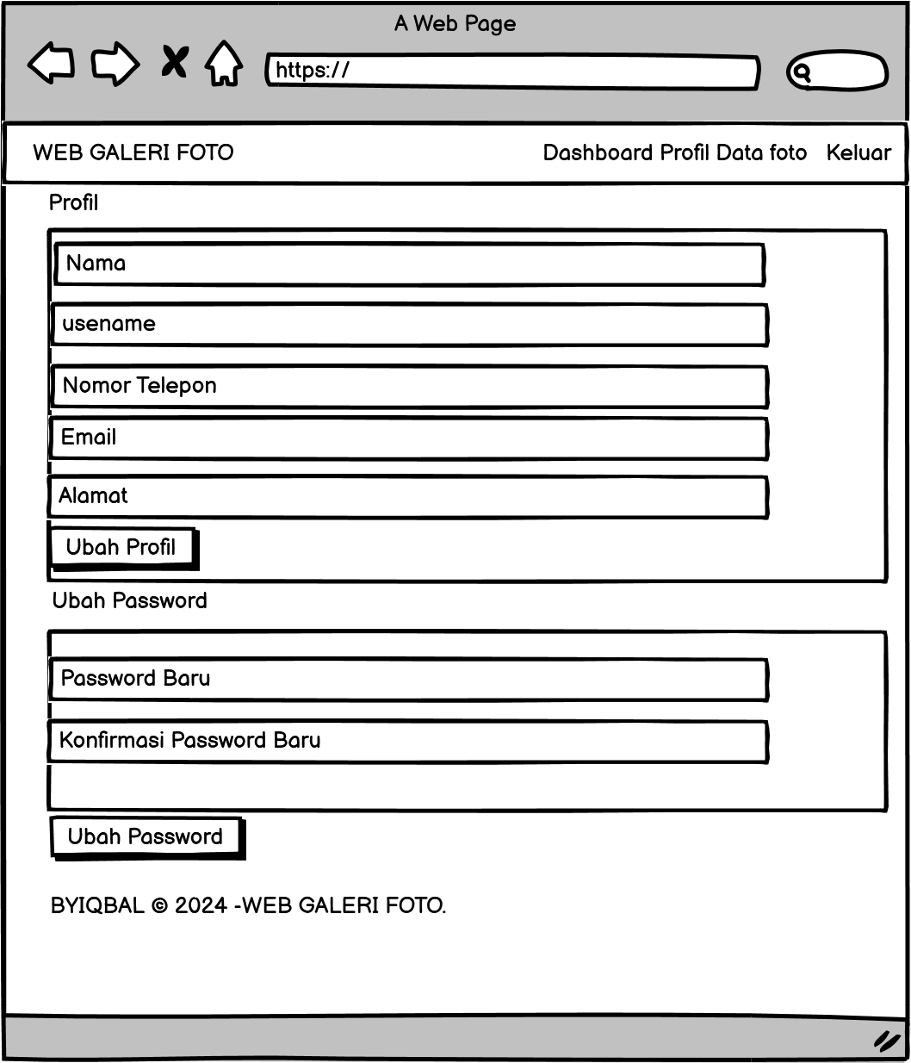

# PEMBUATAN STRUKTUR WEB (HTML)

|  |
| --- |
| <!DOCTYPE html PUBLIC "-//W3C//DTD XHTML 1.0 Transitional//EN" "http://www.w3.org/TR/xhtml1/DTD/xhtml1-transitional.dtd">  <html xmlns="http://www.w3.org/1999/xhtml">  <head>  <meta charset="utf-8">  <meta name="viewport" content="width=device-width, initial-scale=1">  <title>WEB GALERI FOTO</title>  <link rel="stylesheet" type="text/css" href="stylee.css">  </head>  <body>  <!-- header -->  <header>  <div class="container">  <h1><a href="dashboard.php">WEB GALERI FOTO</a></h1>  <ul>  <li><a href="dashboard.php">Dashboard</a></li>  <li><a href="profil.php">Profil</a></li>  <li><a href="data-image.php">Data Foto</a></li>  <li><a href="Keluar.php">Keluar</a></li>  </ul>  </div>  </header>    <!-- content -->  <div class="section">  <div class="container">  <h3>Dashboard</h3>  <div class="box">  <h4>WELCOME <?php echo $_SESSION['a_global']->admin_name ?> TO WEBSITE GALERI FOTO</h4>  </div>  </div>  </div>    <!-- footer -->  <footer>  <div class="container">  <small>BYIQBAL &copy; 2024 -WEB GALERI FOTO.</small>  </div>  </footer>  </body>  </html> |

1. PEMBUATAN STYLE WEB

|  |
| --- |
| @charset "utf-8";  /* CSS Document */  * {  padding:0;  margin:0;  font-family:'Quicksand', sans-serif;  }  body {  background-color:#f8f8f8;  }  a {  color: inherit;  text-decoration:none;  }  #bg-login {  display: flex;  height: 100vh;  justify-content: center;  align-items: center;  }  .box-login {  width: 300px;  min-height: 200px;  border:1px solid #ccc;  background-color: #fff;  padding:15px;  box-sizing:border-box;  }  .box-login h2 {  text-align:center;  margin-bottom:15px;  }  .input-control {  width:100%;  padding:10px;  margin-bottom:15px;  box-sizing:border-box;  }  .btn {  padding:8px 15px;  background-color: #00e1ff;  color: #fff;  border:none;  cursor: pointer;  }  header {  background-color: #00f7ff;  color: #fff;  }  header h1 {  float:left;  padding:10px 0;  }  header ul {  float:right;  }  header ul li {  display:inline-block;  }  header ul li a {  padding:20px 0 20px 15px;  display: inline-block;  }  footer {  padding:25px 0;  }  .container {  width: 80%;  margin: 0 auto;  }  .container:after {  content:'';  display: block;  clear:both;  }  .section {  padding:25px 0;  }  .box {  background-color: #fff;  border:1px solid #ccc;  padding:15px;  box-sizing: border-box;  margin:10px 0 25px 0;  }  .box:after {  content: '';  display: block;  clear: both;  }  .table {  width: 100%;  border-collapse: collapse;  }  .table tr {  height: 30px;  }  .table tr td {  padding:5px 10px;  }  .search {  padding:15px 0;  background-color: #fff;  border:1px solid #ccc;  text-align: center;  }  .search input[type=text] {  width: 60%;  padding:10px;  }  .search input[type=submit] {  padding:12px 15px;  background-color: #00e1ff;  color: #fff;  border:none;  cursor:pointer;  }  .col-5 {  width:20%;  height:100px;  text-align: center;  float: left;  padding:10px;  box-sizing: border-box;  }  .col-4 {  width:25%;  height: 230px;  border:1px solid #ccc;  float: left;  padding:10px;  box-sizing: border-box;  margin-bottom: 10px;  }  .col-4:hover {  box-shadow: 0 0 3px #999;  }  .col-4 img {  width: 50%;  }  .col-4 .nama {  font-weight: bold;  color: #666;  margin-bottom: 5px;  }  .col-4 .admin {  font-weight: bold;  color: #00ffff;  }  .footer {  padding:25px 0;  background-color: #333;  color: #fff;  text-align: center;  }  .footer p {  margin-bottom: 10px;  }  .footer small {  margin-top: 25px;  display: inline-block;  }  .col-2 {  width: 50%;  min-height: 200px;  padding:10px;  box-sizing: border-box;  float: left;  }  .col-2 img {  border:10px solid #f9f9f9;  padding:50px;  box-sizing: border-box;  }  .col-2 h3 {  margin-bottom: 10px;  }  .col-2 h4 {  color: #00ffea;  }  .col-2 p {  margin:15px 0;  text-align: justify;  line-height: 25px;  font-size: 14px;  }  @media screen and (max-width: 768px) {  .container {  width: 90%;  }  .col-5 {  width:50%;  margin-bottom: 10px;  }  .col-4 {  width:50%;  height: 300px;  }  .col-2 {  width:100%;  }  } |

1. PEMBUATAN KODE WEB

File index.php

|  |
| --- |
| <?php  include 'db.php';  $kontak = mysqli_query($db, "SELECT admin_telp, admin_email, admin_address FROM tb_admin WHERE admin_id = 2");  $a = mysqli_fetch_object($kontak);  ?>  <!DOCTYPE html PUBLIC "-//W3C//DTD XHTML 1.0 Transitional//EN" "http://www.w3.org/TR/xhtml1/DTD/xhtml1-transitional.dtd">  <html xmlns="http://www.w3.org/1999/xhtml">  <head>  <meta charset="utf-8">  <meta name="viewport" content="width=device-width, initial-scale=1">  <title>WEB GALERI FOTO</title>  <link rel="stylesheet" type="text/css" href="stylee.css">  </head>  <body>  <!-- header -->  <header>  <div class="container">  <h1><a href="index.php">WEB GALERI FOTO</a></h1>  <ul>  <li><a href="galeri.php">Galeri</a></li>  <li><a href="registrasi.php">Registrasi</a></li>  <li><a href="login.php">Login</a></li>  </ul>  </div>  </header>    <!-- search -->  <div class="search">  <div class="container">  <form action="galeri.php">  <input type="text" name="search" placeholder="Cari Foto" />  <input type="submit" name="cari" value="Cari Foto" />  </form>  </div>  </div>    <!-- category -->  <div class="section">  <div class="container">  <h3>Kategori</h3>  <div class="box">  <?php  $kategori = mysqli_query($db, "SELECT * FROM tb_category ORDER BY category_id DESC");  if(mysqli_num_rows($kategori) > 0){  while($k = mysqli_fetch_array($kategori)){  ?>  <a href="galeri.php?kat=<?php echo $k['category_id'] ?>">  <div class="col-5">  <img src="img/logo.png" width="30px" style="margin-bottom:3px;" />  <p><?php echo $k['category_name'] ?></p>  </div>  </a>  <?php }}else{ ?>  <p>Kategori tidak ada</p>  <?php } ?>  </div>  </div>  </div>    <!-- new product -->  <div class="container">  <h3>Foto Terbaru</h3>  <div class="box">  <?php  $foto = mysqli_query($db, "SELECT * FROM tb_image WHERE image_status = 1 ORDER BY image_id DESC LIMIT 8");  if(mysqli_num_rows($foto) > 0){  while($p = mysqli_fetch_array($foto)){  ?>  <a href="detail-image.php?id=<?php echo $p['image_id'] ?>">  <div class="col-4">  <img src="foto/<?php echo $p['image'] ?>" height="150px" />  <p class="nama"><?php echo substr($p['image_name'], 0, 30) ?></p>  <p class="admin">Nama User : <?php echo $p['admin_name'] ?></p>  <p class="nama"><?php echo $p['date_created'] ?></p>  </div>  </a>  <?php }}else{ ?>  <p>Foto tidak ada</p>  <?php } ?>  </div>  </div>    <!-- footer -->  <footer>  <div class="container">  <small>BYIQBAL &copy; 2024 -WEB GALERI FOTO.</small>  </div>  </footer>  </body>  </html> |

File koneksi.php

|  |
| --- |
| <?php  $hostname = 'localhost';  $username = 'root';  $password = '';  $dbname = 'galerifoto1';    $db = mysqli_connect($hostname, $username, $password, $dbname) or die ('gagal terhubung ke database');  ?> |

CRUD file index.php

* Creat

|  |
| --- |
| <?php  include 'db.php';  $kontak = mysqli_query($db, "SELECT admin_telp, admin_email, admin_address FROM tb_admin WHERE admin_id = 2");  $a = mysqli_fetch_object($kontak);  ?>  <!DOCTYPE html PUBLIC "-//W3C//DTD XHTML 1.0 Transitional//EN" "http://www.w3.org/TR/xhtml1/DTD/xhtml1-transitional.dtd">  <html xmlns="http://www.w3.org/1999/xhtml">  <head>  <meta charset="utf-8">  <meta name="viewport" content="width=device-width, initial-scale=1">  <title>WEB GALERI FOTO</title>  <link rel="stylesheet" type="text/css" href="stylee.css">  </head>  <body>  <!-- header -->  <header>  <div class="container">  <h1><a href="index.php">WEB GALERI FOTO</a></h1>  <ul>  <li><a href="galeri.php">Galeri</a></li>  <li><a href="registrasi.php">Registrasi</a></li>  <li><a href="login.php">Login</a></li>  </ul>  </div>  </header>    <!-- search -->  <div class="search">  <div class="container">  <form action="galeri.php">  <input type="text" name="search" placeholder="Cari Foto" />  <input type="submit" name="cari" value="Cari Foto" />  </form>  </div>  </div>    <!-- category -->  <div class="section">  <div class="container">  <h3>Kategori</h3>  <div class="box">  <?php  $kategori = mysqli_query($db, "SELECT * FROM tb_category ORDER BY category_id DESC");  if(mysqli_num_rows($kategori) > 0){  while($k = mysqli_fetch_array($kategori)){  ?>  <a href="galeri.php?kat=<?php echo $k['category_id'] ?>">  <div class="col-5">  <img src="img/logo.png" width="30px" style="margin-bottom:3px;" />  <p><?php echo $k['category_name'] ?></p>  </div>  </a>  <?php }}else{ ?>  <p>Kategori tidak ada</p>  <?php } ?>  </div>  </div>  </div>    <!-- new product -->  <div class="container">  <h3>Foto Terbaru</h3>  <div class="box">  <?php  $foto = mysqli_query($db, "SELECT * FROM tb_image WHERE image_status = 1 ORDER BY image_id DESC LIMIT 8");  if(mysqli_num_rows($foto) > 0){  while($p = mysqli_fetch_array($foto)){  ?>  <a href="detail-image.php?id=<?php echo $p['image_id'] ?>">  <div class="col-4">  <img src="foto/<?php echo $p['image'] ?>" height="150px" />  <p class="nama"><?php echo substr($p['image_name'], 0, 30) ?></p>  <p class="admin">Nama User : <?php echo $p['admin_name'] ?></p>  <p class="nama"><?php echo $p['date_created'] ?></p>  </div>  </a>  <?php }}else{ ?>  <p>Foto tidak ada</p>  <?php } ?>  </div>  </div>    <!-- footer -->  <footer>  <div class="container">  <small>BYIQBAL &copy; 2024 -WEB GALERI FOTO.</small>  </div>  </footer>  </body>  </html> |

* Edit

|  |
| --- |
| <?php  session_start();  include 'db.php';  if($_SESSION['status_login'] != true){  echo '<script>window.location="login.php"</script>';  }    $produk = mysqli_query($db, "SELECT * FROM tb_image WHERE image_id = '".$_GET['id']."'");  if(mysqli_num_rows($produk) == 0){  echo '<script>window.location="data-image.php"</script>';  }  $p = mysqli_fetch_object($produk);  ?>  <!DOCTYPE html PUBLIC "-//W3C//DTD XHTML 1.0 Transitional//EN" "http://www.w3.org/TR/xhtml1/DTD/xhtml1-transitional.dtd">  <html xmlns="http://www.w3.org/1999/xhtml">  <head>  <meta charset="utf-8">  <meta name="viewport" content="width=device-width, initial-scale=1">  <title>WEB GALERI FOTO</title>  <link rel="stylesheet" type="text/css" href="stylee.css">  <script src="https://cdn.ckeditor.com/4.20.0/standard/ckeditor.js"></script>  </head>  <body>  <!-- header -->  <header>  <div class="container">  <h1><a href="dashboard.php">WEB GALERI FOTO</a></h1>  <ul>  <li><a href="dashboard.php">Dashboard</a></li>  <li><a href="profil.php">Profil</a></li>  <li><a href="data-image.php">Data Foto</a></li>  <li><a href="Keluar.php">Keluar</a></li>  </ul>  </div>  </header>    <!-- content -->  <div class="section">  <div class="container">  <h3>Edit Data Foto</h3>  <div class="box">  <form action="" method="POST" enctype="multipart/form-data">  <input type="text" name="kategori" class="input-control" placeholder="Kategori Foto" value="<?php echo $p->category_name ?>" readonly="readonly">  <input type="text" name="namauser" class="input-control" placeholder="Nama User" value="<?php echo $p->admin_name ?>" readonly="readonly">  <input type="text" name="nama" class="input-control" placeholder="Nama Foto" value="<?php echo $p->image_name ?>" required>    <img src="foto/<?php echo $p->image ?>" width="100px" />  <input type="hidden" name="foto" value="<?php echo $p->image ?>" />  <input type="file" name="gambar" class="input-control">  <textarea class="input-control" name="deskripsi" placeholder="Deskripsi"><?php echo $p->image_description ?></textarea><br />  <select class="input-control" name="status">  <option value="">--Pilih--</option>  <option value="1" <?php echo ($p->image_status == 1)? 'selected':''; ?>>Aktif</option>  <option value="0"<?php echo ($p->image_status == 0)? 'selected':''; ?>>Tidak Aktif</option>  </select>  <input type="submit" name="submit" value="Submit" class="btn">  </form>  <?php  if(isset($_POST['submit'])){    // data inputan dari form  $kategori = $_POST['kategori'];  $user = $_POST['namauser'];  $nama = $_POST['nama'];  $deskripsi = $_POST['deskripsi'];  $status = $_POST['status'];  $foto = $_POST['foto'];    // data gambar yang baru  $filename = $_FILES['gambar']['name'];  $tmp_name = $_FILES['gambar']['tmp_name'];    //jika admin ganti gambar  if($filename != ''){    $type1 = explode('.', $filename);  $type2 = $type1[1];  $newname = 'foto'.time().'.'.$type2;    // menampung data format file yang diizinkan  $tipe_diizinkan = array('jpg', 'jpeg', 'png', 'gif');    // validasi format file  if(!in_array($type2, $tipe_diizinkan)){  // jika format file tidak ada di dalam tipe diizinkan  echo '<script>alert("Format file tidak diizinkan")</script>';    }else{  unlink('./foto/'.$foto);  move_uploaded_file($tmp_name, './foto/'.$newname);  $namagambar = $newname;  }    }else{  // jika admin tidak ganti gambar  $namagambar = $foto;    }    //query update data produk  $update = mysqli_query($db, "UPDATE tb_image SET  category_name = '".$kategori."',  admin_name = '".$user."',  image_name = '".$nama."',  image_description = '".$deskripsi."',  image = '".$namagambar."',  image_status = '".$status."'  WHERE image_id = '".$p->image_id."' ");  if($update){  echo '<script>alert("Ubah data berhasil")</script>';  echo '<script>window.location="data-image.php"</script>';  }else{  echo 'gagal'.mysqli_error($db);    }  }  ?>  </div>  </div>  </div>    <!-- footer -->  <footer>  <div class="container">  <small>BYIQBAL &copy; 2024 -WEB GALERI FOTO.</small>  </div>  </footer>  <script>  CKEDITOR.replace( 'deskripsi' );  </script>  </body>  </html> |

* Tambah

|  |
| --- |
| <?php  session_start();  include 'db.php';  if($_SESSION['status_login'] != true){  echo '<script>window.location="login.php"</script>';  }  ?>  <!DOCTYPE html PUBLIC "-//W3C//DTD XHTML 1.0 Transitional//EN" "http://www.w3.org/TR/xhtml1/DTD/xhtml1-transitional.dtd">  <html xmlns="http://www.w3.org/1999/xhtml">  <head>  <meta charset="utf-8">  <meta name="viewport" content="width=device-width, initial-scale=1">  <title>WEB GALERI FOTO</title>s  <link rel="stylesheet" type="text/css" href="stylee.css">  </head>  <body>  <!-- header -->  <header>  <div class="container">  <h1><a href="dashboard.php">WEB GALERI FOTO</a></h1>  <ul>  <li><a href="dashboard.php">Dashboard</a></li>  <li><a href="profil.php">Profil</a></li>  <li><a href="data-image.php">Data Foto</a></li>  <li><a href="Keluar.php">Keluar</a></li>  </ul>  </div>  </header>  <!-- content -->  <div class="section">  <div class="container">  <h3>Tambah Data Foto</h3>  <div class="box">  <form action="" method="POST" enctype="multipart/form-data">  <?php $result = mysqli_query($db,"select * from tb_category"); $jsArray = "var prdName = new Array();\n";  echo '<select class="input-control" name="kategori" onchange="document.getElementById(\'prd_name\').value = prdName[this.value]" required> <option>-Pilih Kategori Foto-</option>';while ($row = mysqli_fetch_array($result)) { echo ' <option value="' . $row['category_id'] . '">' . $row['category_name'] . '</option>';  $jsArray .= "prdName['" . $row['category_id'] . "'] = '" . addslashes($row['category_name']) . "';\n";}echo '</select>';?>  </select>  <input type="hidden" name="nama_kategori" id="prd_name">  <input type="hidden" name="adminid" value="<?php echo $_SESSION['a_global']->admin_id ?>">  <input type="text" name="namaadmin" class="input-control" value="<?php echo $_SESSION['a_global']->admin_name ?>" readonly="readonly">  <input type="text" name="nama" class="input-control" placeholder="Nama Foto" required>  <textarea class="input-control" name="deskripsi" placeholder="Deskripsi"></textarea><br />  <input type="file" name="gambar" class="input-control" required>  <select class="input-control" name="status">  <option value="">--Pilih--</option>  <option value="1">Aktif</option>  <option value="0">Tidak Aktif</option>  </select>  <input type="submit" name="submit" value="Submit" class="btn">  </form>  <?php  if(isset($_POST['submit'])){  // print_r($_FILES[gambar']);  // menampung inputan dari form  $kategori = $_POST['kategori'];  $nama_ka = $_POST['nama_kategori'];  $ida = $_POST['adminid'];  $user = $_POST['namaadmin'];  $nama = $_POST['nama'];  $deskripsi = $_POST['deskripsi'];  $status = $_POST['status'];  // menampung data file yang diupload  $filename = $_FILES['gambar']['name'];  $tmp_name = $_FILES['gambar']['tmp_name'];  $type1 = explode('.', $filename);  $type2 = $type1[1];  $newname = 'foto'.time().'.'.$type2;  // menampung data format file yang diizinkan  $tipe_diizinkan = array('jpg', 'jpeg', 'png', 'gif');  // validasi format file  if(!in_array($type2, $tipe_diizinkan)){  // jika format file tidak ada di dalam tipe diizinkan  echo '<script>alert("Format file tidak diizinkan")</script>';  }else{  // jika format file sesuai dengan yang ada di dalam array tipe diizinkan  // proses upload file sekaligus insert ke database  move_uploaded_file($tmp_name, './foto/'.$newname);  $insert = mysqli_query($db, "INSERT INTO tb_image VALUES (  null,  '".$kategori."',  '".$nama_ka."',  '".$ida."',  '".$user."',  '".$nama."',  '".$deskripsi."',  '".$newname."',  '".$status."',  null  ) ");  if($insert){  echo '<script>alert("Tambah Foto berhasil")</script>';  echo '<script>window.location="data-image.php"</script>';  }else{  echo 'gagal'.mysqli_error($db);  }  }  }  ?>  </div>  </div>  </div>  <!-- footer -->  <footer>  <div class="container">  <small>BYIQBAL &copy; 2024 -WEB GALERI FOTO.</small>  </div>  </footer>  <script>  CKEDITOR.replace( 'deskripsi' );  </script>  <script type="text/javascript"><?php echo $jsArray; ?></script>  </body>  </html> |

* Hapus

|  |
| --- |
| <?php  include 'db.php';  if(isset($_GET['idp'])){  $foto = mysqli_query($db, "SELECT image FROM tb_image WHERE image_id = '".$_GET['idp']."' ");  $p = mysqli_fetch_object($foto);  unlink('./foto/'.$p->image);  $delete = mysqli_query($db, "DELETE FROM tb_image WHERE image_id = '".$_GET['idp']."' ");  echo '<script>window.location="data-image.php"</script>';  }  ?> |

1. UJI COBA
2. Pengujian *form login user*

|  |  |  |  |  |  |
| --- | --- | --- | --- | --- | --- |
| No. | Skenario  Pengujian | *Test Case* | Hasil yang Diharapkan | Hasil  Pengujian | Kesimpulan |
| 1 | *Username* dan *Password* tidak diisi kemudian klik tombol Login | Username: (kosong)  Password: (kosong) | Sistem akan menolak dan menampilkan pesan  “Username atau password anda salah” | Sesuai harapan | Valid |
| 2 | Mengetikkan Username, dan password tidak diisi atau kosong kemudian klik  tombol Login | Username: admin  Password: (kosong) | Sistem akan menolak dan menampilkan pesan  “Username atau password anda salah” | Sesuai harapan | Valid |
| 3 | Mengetikkan Password, dan username tidak diisi atau kosong kemudian klik  tombol Login | Username: (kosong)  Password: 2005 | Sistem akan menolak dan menampilkan pesan  “Username atau password anda salah” | Sesuai harapan | Valid |
| 4 | Mengetikkan Username dan/atau password tidak  sesuai, kemudian klik tombol Login | Username: bal  Password: 2005 | Sistem akan menolak dan menampilkan pesan  “Username atau password anda salah” | Sesuai harapan | Valid |
| 5 | Mengetikkan Username dan password (diisi), kemudian klik  tombol Login | Username: purr  Password: 2005 | Sistem menerima akses login dan kemudian menampilkan halaman dashboard | Sesuai harapan | Valid |

1. Pengujian form tambah foto

|  |  |  |  |  |  |
| --- | --- | --- | --- | --- | --- |
| No. | Skenario  Pengujian | *Test Case* | Hasil yang Diharapkan | Hasil  Pengujian | Kesimpulan |
| 1 | Pilih kategori foto,id foto,Nama foto,Deskripsi,masukan foto,Pilih aksi, lalu klik submit | Menekan Tombol Tambah Data tanpa mengisi data | Sistem akan menolak dan menampilkan pesan  “Please fill out this field” | Sesuai harapan | Valid |
| 2 | Pilih kategori foto,id foto,Nama foto,Deskripsi,masukan foto,Pilih aksi, lalu klik submit | Menekan Tombol Tambah Data dengan hanya Sebagian data yang diisi | Sistem akan menolak dan menampilkan pesan  “Please select a file” | Sesuai harapan | Valid |
| 3 | Pilih kategori foto,id foto,Nama foto,Deskripsi,masukan foto,Pilih aksi, lalu klik submit | Menekan Tombol Tambah Data setelah Semua Data Sudah Diisi | Sistem akan menampilkan pesan  “Tambah Data Foto Berhasil” | Sesuai harapan | Valid |

1. Pengujian *form* edit foto

|  |  |  |  |  |  |
| --- | --- | --- | --- | --- | --- |
| No. | Skenario  Pengujian | *Test Case* | Hasil yang Diharapkan | Hasil  Pengujian | Kesimpulan |
| 1 | Pilih data galeri foto,Pilih aksi edit | Mengisi form edit tanpa mengisi datanya lalu klik submit | Sistem akan menolak dan menampilkan pesan  “Please fill out this field” | Sesuai harapan | Valid |
| 2 | Pilih data galeri foto,Pilih aksi edit | Mengisi form edit hanya sebagian yang diiisi lalu klik submit | Sistem akan menampilkan pesan  “Ubah data berhasil” | Sesuai harapan | Valid |
| 3 | Pilih data galeri foto,Pilih aksi edit | Mengisi form edit foto Saat Semua Data Sudah Diisi | Sistem akan mengakses dan menampilkan pesan  “Tambah Data Berhasil” | Sesuai harapan | Valid |

1. Hapus foto

|  |  |  |  |  |  |
| --- | --- | --- | --- | --- | --- |
| No. | Skenario  Pengujian | *Test Case* | Hasil yang Diharapkan | Hasil  Pengujian | Kesimpulan |
| 1 | Pilih data galeri foto,Pilih aksi Hapus foto | Klik tombol “Ok” | Sistem akan menampilkan Lagi ke halaman data galeri foto | Sesuai harapan | Valid |

1. REVISI
2. PENENTUAN DOMAIN DAN HOSTING
3. UPLOAD WEB KE HOSTING
4. UPLOAD WEB KE GITHUB
5. PEMBUATAN USER GUIDANCE